NS60二相混合式步进电机 60mm 2phase hybrid stepper motor
项目(Item) |  | 性能(Specifications) |  |  | 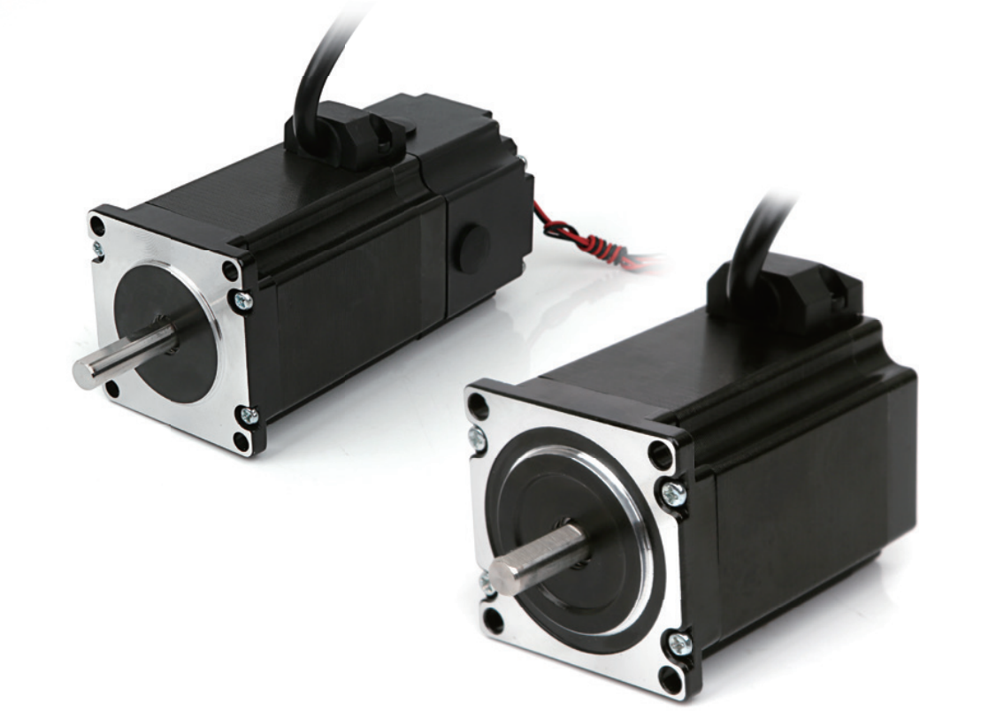
步距角(Step Angle) |  | 1.8°
温 升(Temperature Rise) |  | 80℃max
环境温度（Ambient Temperature） |  | -20℃~+50℃
绝缘电阻(Insulation Resistance) |  | 100 M Ω Min. ,500VDC
电气强度(Dielectric Strength) |  | 500VAC for 1minute
径向间隙(Shaft Radial Play) |  | 0.02Max. (450g-load)
轴向间隙(Shaft Axial Play) |  | 0.08Max. (450g-load)
最大径向压力(Max. radial force) |  | 75N (20mmfrom the flange)
最大轴向压力(Max. axial force) |  | 15N
型 号 Model No. |  | 步距角Step Angle | 电流Current  /Phase | 电阻Resistance  /Phase | 电感Inductance  /Phase | 静力矩Holding Torque | 引线 # of Leads | 转子惯Detent Torque | 机身长Motor Length | 重量 Mass
单轴 | 双轴 | ° | A | Ω | MH | N.M | No. | g-cm2 | (L)mm | Kg
NS60HD56-8D | NS60HD56-SZ-8D | 1.8 | 4.2 | 0.4 | 1.2 | 1.6 | 4 | 350 | 56 | 0.7
NS60HD67-8D | NS60HD67-SZ-8D | 1.8 | 4.2 | 0.55 | 1.2 | 2.0 | 4 | 450 | 67 | 0.9
NS60HD85-8D | NS60HD85-SZ-8D | 1.8 | 4.2 | 0.7 | 2.8 | 2.6 | 4 | 780 | 85 | 1.4
NS60HD100-8D | NS60HD100-SZ-8D | 1.8 | 4.2 | 0.7 | 3 | 3.2 | 4 | 900 | 100 | 1.6
NS60HD112-8D | NS60HD112-SZ-8D | 1.8 | 4.2 | 0.85 | 3.5 | 3.8 | 4 | 900 | 112 | 1.8

